Features Request
- The QA list said that we can search by TP-NWF ids, but it doesn't actually work. Need to fix the audit by TP-NWF ids function. 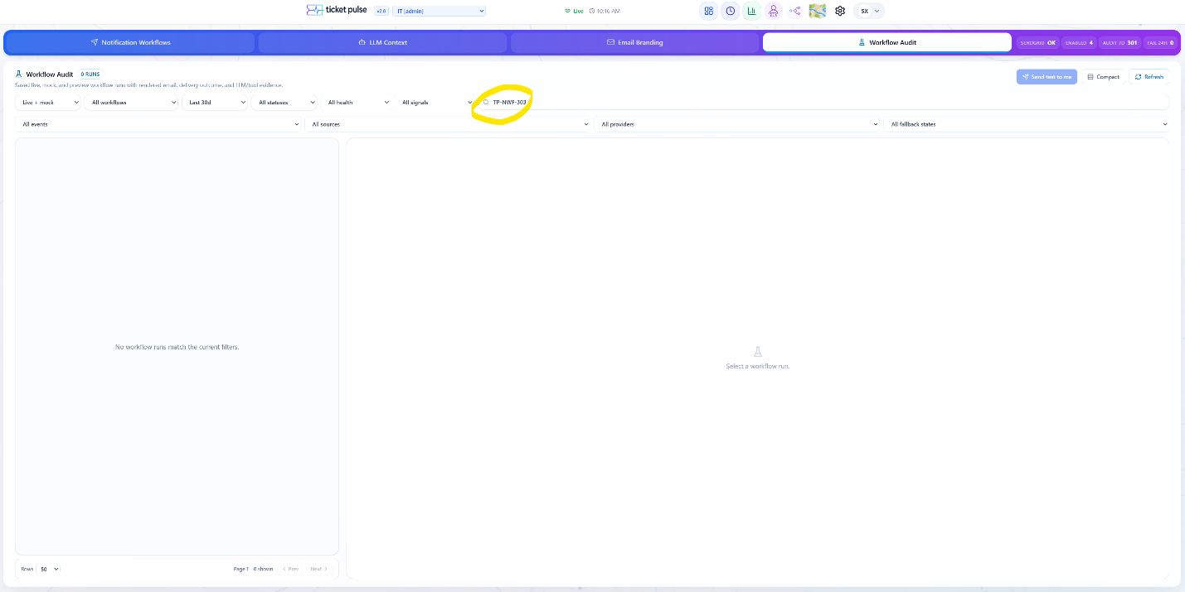

- When a workflow is archived (deleted), it’s not deleted from the workflow dropdown menu in the workflow audit bar. 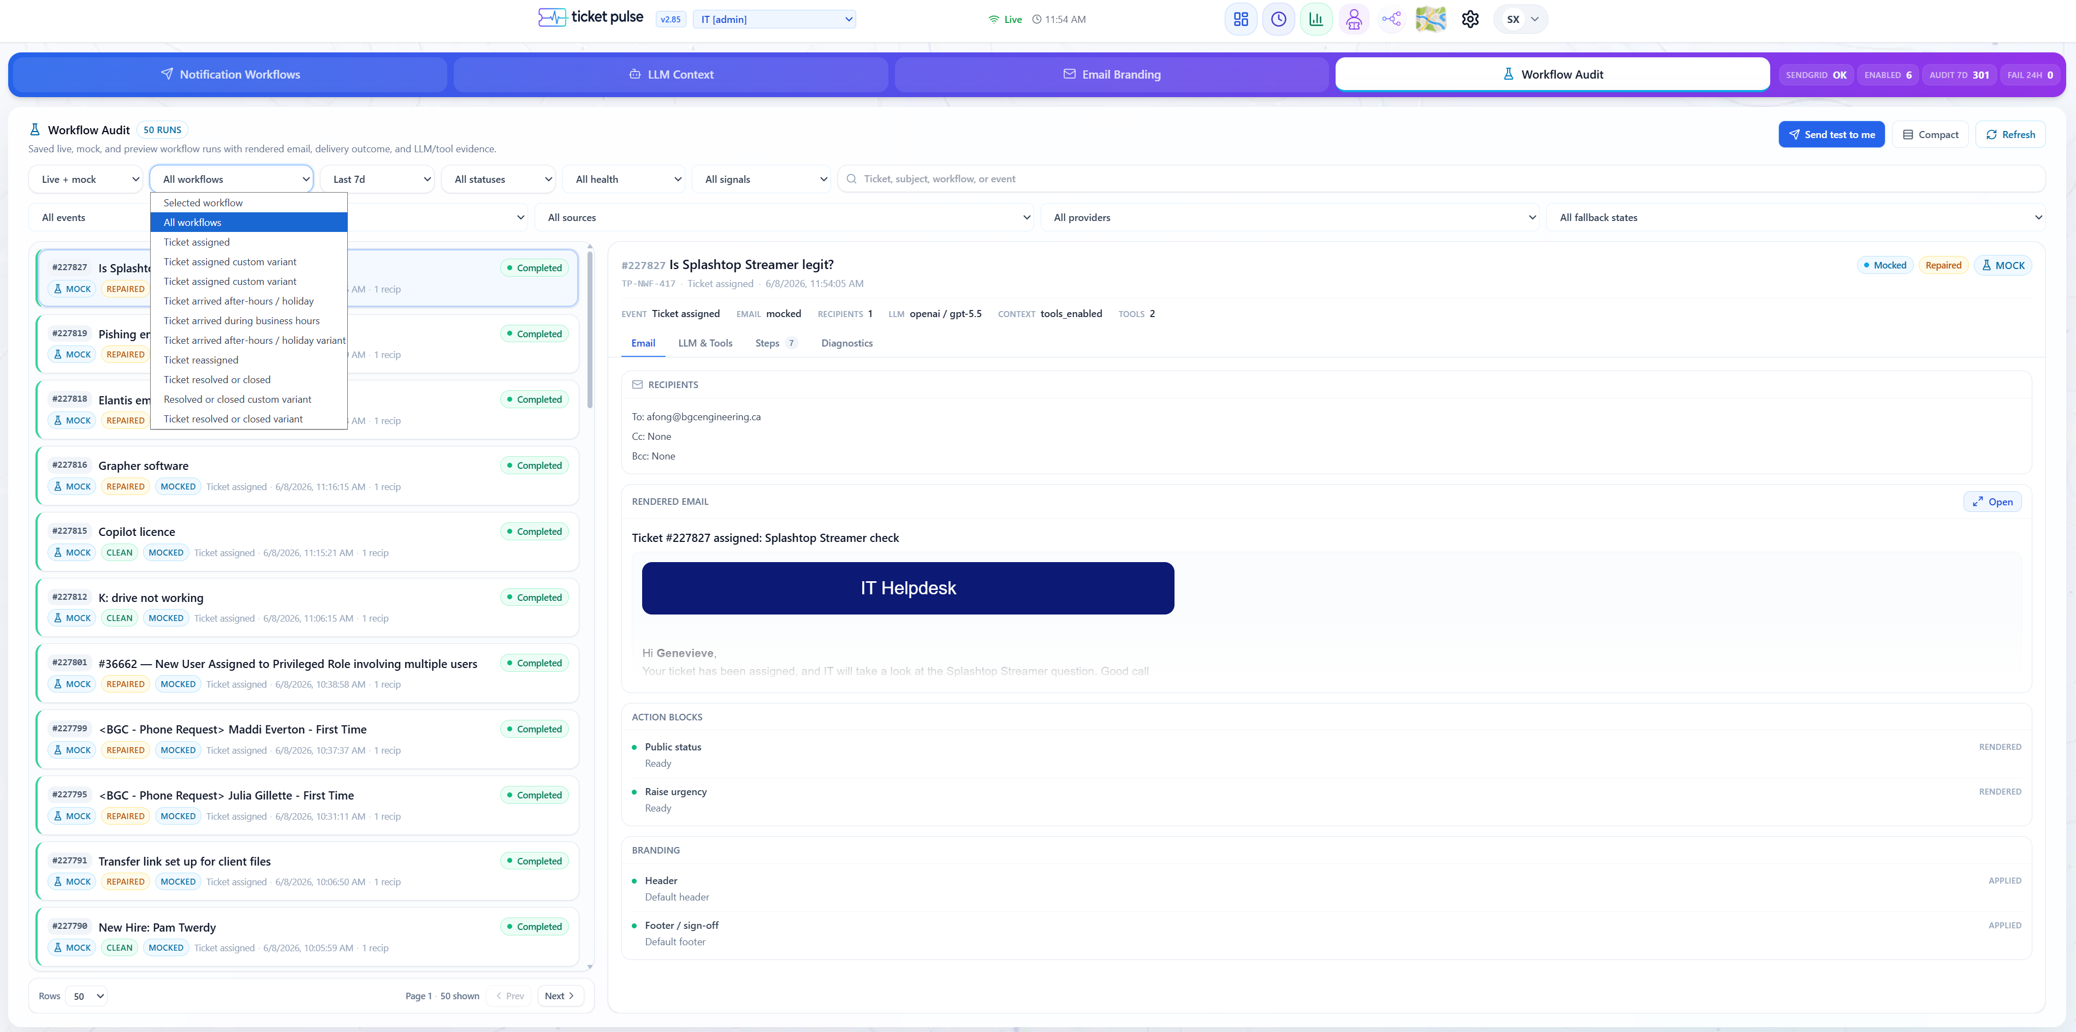

- The UI of the LLM Context page can be improved. Organize all the controls on the left panel into clearly separated functional sections, instead of having all the controls in a dense heap bunched together. Keep the preview panel on the right side the same.